# Napkin drawing feedback from Christian, Stanley, and Temesgen

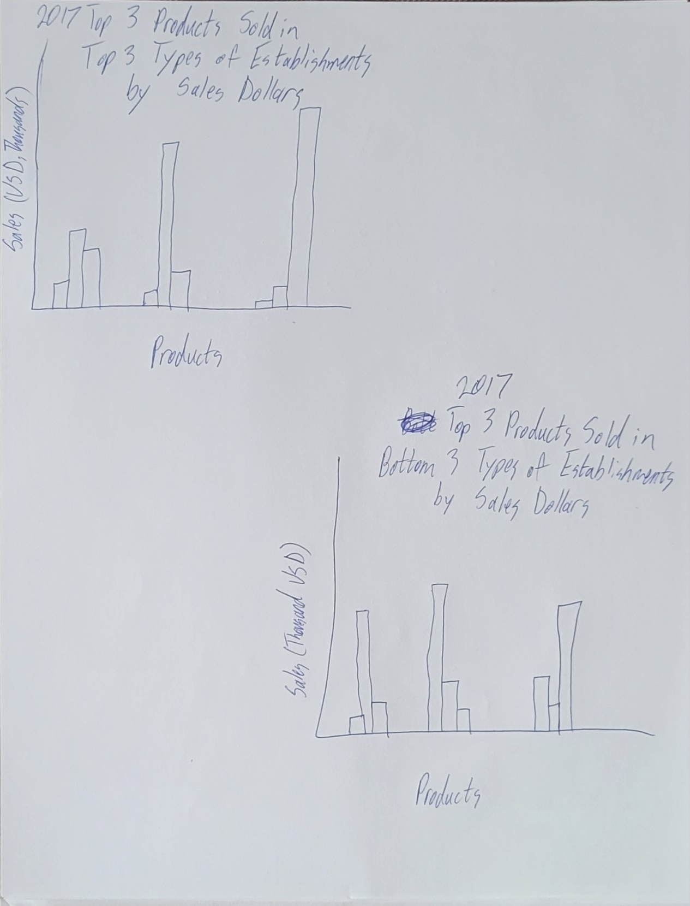

Temesgen - Both charts: Add a legend to help clarify which bar represents which type of establishment

Christian - In the product-sales bar charts, you may wanna have a variation of clustering the bars by product and then by establishment (that was one thing Patrick suggested to one of my groups in the past – I guess it just offers different ways of looking at the same data). If you decide to try clustering by establishment, I would suggest using consistent colors for the products so it’s easy for the audience when they go from one chart to another

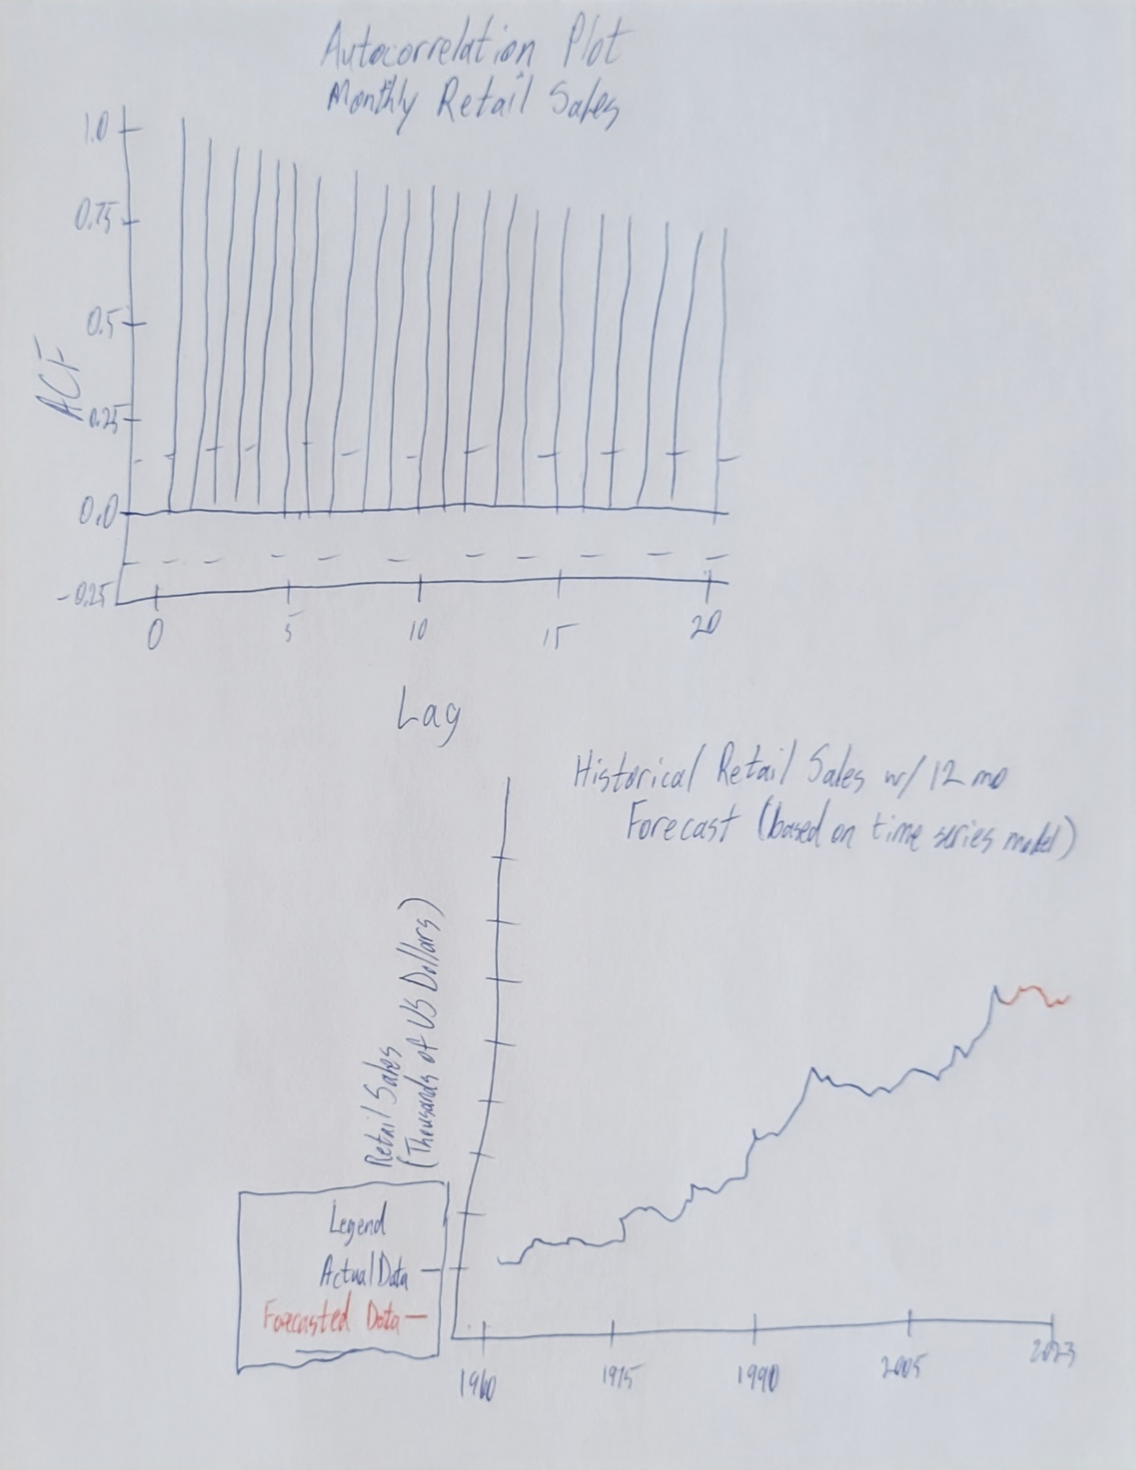

Temesgen - Chart 1: Not sure what ACF and Lag mean, might be good to clarify or explain for a non-technical audience.

Christian - The ACF plot could maybe have the area between the dashed lines grayed out (and label as “no statistical significance” – or whatever it was).

Temesgen - Chart 2: If possible, having the forecasted section of the chart be a dotted line would be a good indicator of predictions.

Christian - I like your historical retail sales with forecast plot and how you highlighted the forecast as red.

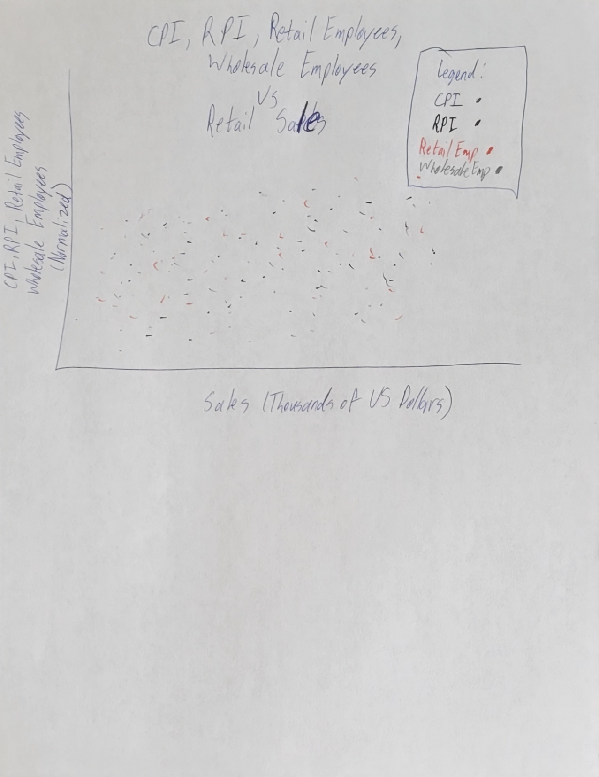

Temesgen - Depending on the results, it might be better to either split the scatter plot into 2 different plots (one for CPI and RPI, one for Retail and Wholesale employees) or add a slicer to the legend. Having 4 different scatter plots merged together might be a little confusing visually.

Stanley - Seems like there's a lot of information going on in that chart. Maybe you wanna have a filter for it so it's easier on the eyes and visually understandable. That's the only suggestion I have

Christian - Similar to Stanley on that CPI, RPI, Retail graph regarding it having a lot of info: you could either do his suggestion with the filter or just make sure the colors contrast enough (but be mindful to include colorblind-friendly colors)

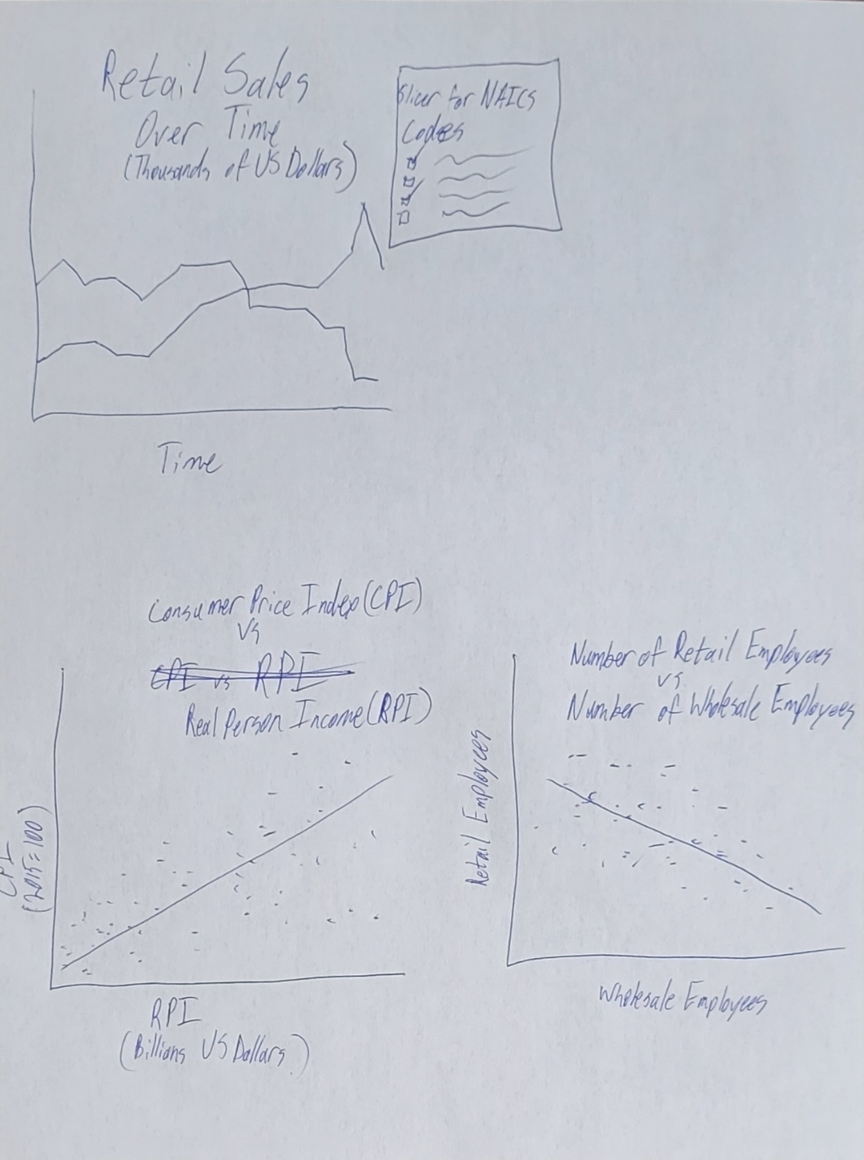

Temesgen - Chart 1: Think about how many codes will be in the slicer and what types of colors or styles you will use for each line.

Christian - In the retail sales over time, I am not sure what the two lines are but I assume that will be clear from the slicer.

Christian - CPI vs RPI looks good. I would just say to make your trendline pop by making it a different color. Same goes for Retail employees vs wholesale.